Press Release

Control cabinets for 5G mobile communication

As interconnection of industrial plants and equipment becomes ever more important and more common, and the introduction of the 5G standard drastically increases data rates, promising an even higher usability potential of wireless communication, FIBOX ARCA wall-mounted enclosures offer optimal protection for radio modems and other telecommunications devices. The control cabinets made of glass-fiber reinforced polycarbonate are extremely robust and low-maintenance. They let radio waves pass through unhindered so that no special measures are necessary when integrating Wi-Fi or other radio applications – devices can simply be installed inside the housing, without openings for antennas. This eliminates the need for machining and sealing enclosures just to feed through antennas. The absence of external antennas reduces the risk of damage due to mechanical impacts such as by vandalism or during transport. Since current EMC device standards no longer require overall shielding of the electronics in control cabinets, the once weighty argument for metal cabinets is now obsolete. At the same time, ARCA series plastic control cabinets offer considerable advantages over standard sheet-metal enclosures: they only weigh half of what same-sized metal versions weigh, they are equally suitable for harsh, demanding indoor and outdoor applications, and at comparable prices. The polycarbonate enclosures with foamed PUR gaskets feature IP66/IP67 ingress protection. They permanently withstand ambient temperatures between -40 °C and 80 °C and provide high protection against vandalism, featuring impact resistance ratings up to IK10. Dents and deformations, which were a persistent threat to the sealing performance of metal control cabinets, become a thing of the past with the switch to ARCA. Lastly, grounding is no longer necessary due to the plastic enclosures' protective insulation.

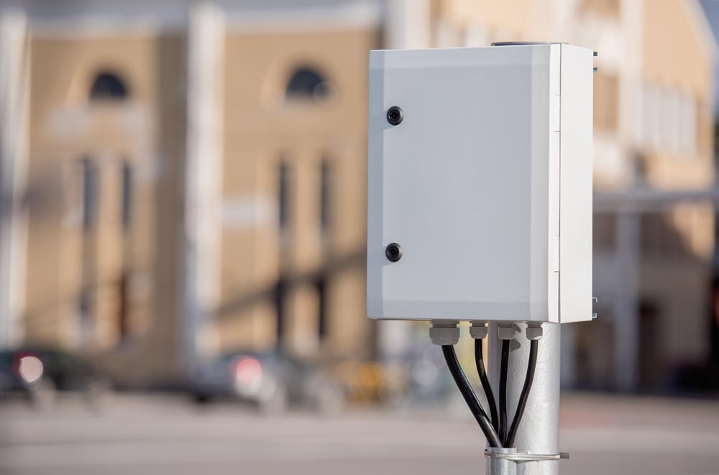
Illustration: Robust ARCA polycarbonate enclosures provide optimum protection for wireless communication devices

Illustrations: | ARCA_1 | Char.s: | 1890
File name: | 201907020_pm_arca_5g_enclosures_en | Date: | 07-24-2019
About FIBOX
The Finnish company FIBOX Oy Ab is one of the leading international suppliers of plastic enclosures for electric and electronic components used in industrial automation as well as information, communication, and medical technology. At present, the FIBOX portfolio features more than 1,000 types of standard enclosures manufactured from polycarbonate, the copolymer ABS, glass fiber polyester, and aluminum that provide ingress protection ratings up to IP66/IP67. For several decades, FIBOX has been actively driving the market for enclosure products and the associated tool and production technologies with original designs. As early as 1966, the company introduced injection-molded polycarbonate enclosures, thus marking the start of a new era in control cabinet manufacturing. FIBOX offers a wide range of services, including customization and marking of individual boards or cabinets as well as the planning and delivery of complete automation systems. A broad range of accessories complements the enclosure solutions.

Contact:  FIBOX GmbH  Hans-Martin Reimler  Rehwinkel 30  32457 Porta Westfalica  Germany  Tel.: +49 . 5731 . 869 460  Fax: +49 . 5731 . 869 4650  Email: hans-martin.reimler@fibox.com  WWW: www.fibox.de | gii die Presse-Agentur GmbH  Immanuelkirchstr. 12  10405 Berlin  Germany  Tel.: +49 . 30 . 5389 650  Fax: +49 . 30 . 5389 6529  Email: info@gii.de  WWW: www.gii.de

