Press Release

Quick turnaround for heavy loads

Intra-logistics expert LOSYCO has added a completely new transportation platform to its LOXrail system: the new, steerable Allrounder trolley enables flexible product alignment and change of direction in assembly lines. Designed for manual or battery-powered operation, the new trolley allows medium-heavy workpieces and assemblies up to 15 tons to be quickly, easily, and safely moved around corners without lifting the load. On the underside of the trolley, there is a mechanical steering system with novel, freely rotatable wheelsets. The wheels feature the tried-and-tested LOXrail profile for smooth running on round rails with minimum friction. The steering platform is designed for easy loading and operation, featuring a low minimum height of only 145 mm. It facilitates work in one-piece flow production lines. The LOXrail track layout can be flexibly adapted to the individual plant at significantly reduced installation costs. The entire conveying system is very low-maintenance and especially dirt-resistant. All components are robust and highly durable. The rails are firmly anchored in the hall floor. In addition to the low-wear steering mechanism, the new platforms are equipped with an innovative braking system to safely stop the load in its track. The brake is activated by pedal, providing for optimal ergonomics. It ensures load-dependent stopping of the trolley without blocking the wheels or leaving traces of abrasion on the floor. LOSYCO custom-builds the new steering platforms for use on LOXrail systems with a 25-mm or 40-mm rail diameter.

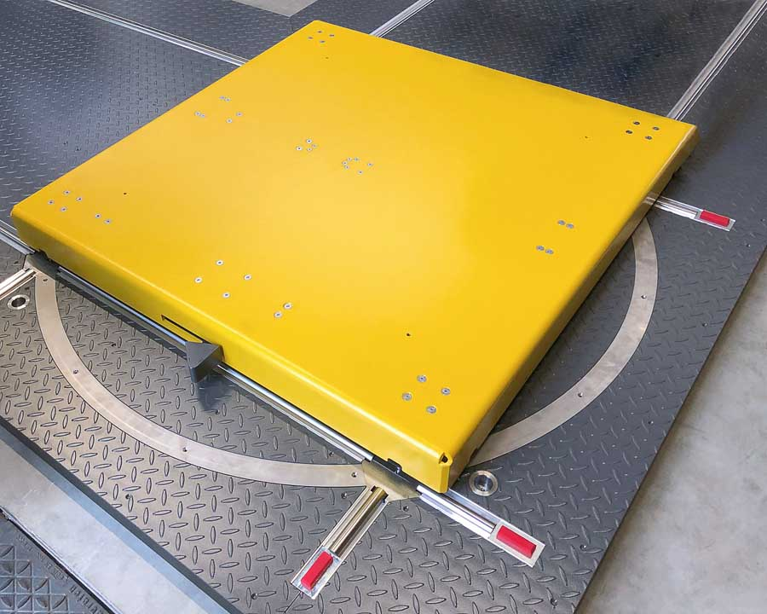
Caption: The new Allrounder steering platform from LOSYCO moves loads around corners, making the LOXrail intra-logistics system even more flexible

Image/s: | allrounder-lenkplattform1 | Characters: | 1567
File name: | 201908015_pm_allrounder_en | Date: | 08-29-2019
About Losyco
Based in Bielefeld, Germany, Losyco designs, manufactures, and deploys intra-logistics systems for industrial customers. Founded by experienced engineers in 2016, the company's first core product is LOXrail®: with this novel round bar rail system, loads weighing several tons can be easily moved around, precisely to the desired spot. It can be operated manually or with auxiliary drives. Losyco also supplies conveying and handling equipment such as chain and roller conveyors, material management and storage systems, sound-proof cabins, and machine covers. In addition, Losyco offers support and guidance for customers wishing to transform their production processes to implement lean manufacturing and continuous flow production. Losyco is a member of the DRECKSHAGE Family.

Contact:  LOSYCO GmbH  Member of the DRECKSHAGE Family  Derek P. Clark  Walter-Werning-Str. 7  33699 Bielefeld  Germany  Tel.: +49 . 521 . 945 643-0  Fax: +49 . 521 . 945 643-399  Email: info@losyco.com  Internet: www.losyco.com | gii die Presse-Agentur GmbH  Immanuelkirchstr. 12  10405 Berlin  Germany  Tel.: +49 . 30 . 538 965-0  Fax: +49 . 30 . 538 965-29  Email: info@gii.de  Internet: www.gii.de

