Press Release

Rugged signal lamp with stainless steel collar and red/green LED

RAFI is expanding its rugged RAFIX 22 FSR control component range with a signal lamp featuring a stainless steel collar with IP65, IP67 and IP69 degree of protection to the front side. The integrated red/green LED can indicate three signal statuses. The translucent indicator is a neutral white in standby mode, green indicates regular operating condition, and red signals faults. The convex signal indicator makes it easy to see the signals from different directions and distances. The lamps have a diameter of 31.3 mm and an installed height of 12.2 mm. Like all RAFIX 22 FS/FSR control and signaling units, they fit standard 22.3 mm installation openings. The mounting depth is 25.45 mm. For the display of different status conditions, the lamps feature wiring over separate terminals with reverse-polarity protection for 2.8 mm x 0.8 mm quick connectors with operating voltages of 8 VDC to 30 VDC.

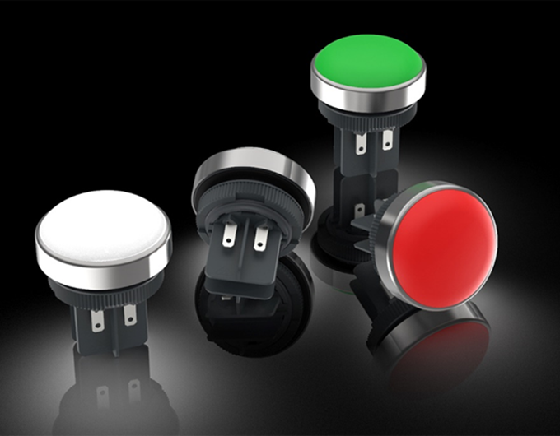
Caption: New RAFIX 22 FSR series signal lights for three reporting modes

Image/s: | RAFIX_FSR_Meldeleuchten | Characters: | 901
File name: | 202102012_pm_RAFIX_22_FSR_signal_lamps_with_redgreen led_en | Date: | 03-04-2021

About the RAFI group
Components and systems for human–machine interaction. The range of products includes pushbuttons, switches, touchscreens, control systems and electronic assemblies. RAFI products are employed in many industries including automation, medical technology, machine and plant engineering, road and railway vehicles, household appliances and telecommunication. The RAFI group operates internationally with 2,000 employees at sites in Germany, Europe, China, and the USA. Its headquarters are in Berg, Germany.
.

Contact:  RAFI GmbH & Co. KG  Artur Krug  Ravensburger Str. 128–134  88276 Berg, Germany  Phone: +49 751 89-1307  Fax: +49 751 89-1300  Email: artur.krug@rafi.de  Internet: www.rafi.de |  | gii die Presse-Agentur GmbH  Immanuelkirchstr. 12  10405 Berlin, Germany  Phone: +49 30 53 89 65-0  Fax: +49 30 53 89 65-29  Email: info@gii.de  Internet: www.gii.de

