Press Release

Pump works, summer is saved

Baden-Württemberg state water supply, a German special-purpose association, urgently needed a new motor for a pump that is only used at peak times during the summer. Since Menzel Elektromotoren had already proven itself as a reliable supplier in the past, nothing was more obvious than a quick call to the Berlin-based manufacturer. Menzel has the largest inventory of industrial motors in Europe and had a suitable three-phase slip ring rotor motor on hand, with a 710 mm shaft height, 3700 kW rated power, and 5000 V rated voltage. A member of staff took the measurements on site in the pumphouse. Since the old, failed motor had a flanged shaft with a permanently fixed coupling half, Menzel procured a new coupling half. The team also welded a base frame to bring the new, more compact motor to the shaft height of original. The existing installation was special in that all supply lines were fed in from below. Therefore, new cable ducts were implemented in the station floor next to the motor, whilst Menzel repositioned the terminal boxes. Menzel staff also commissioned the motor and could therefore check firsthand that the installation was complete and subsequent startup was flawless.
Menzel has manufactured pump motors for a wide range of applications in the past. More information is available at https://www.menzel-motors.com/pump-drive/.

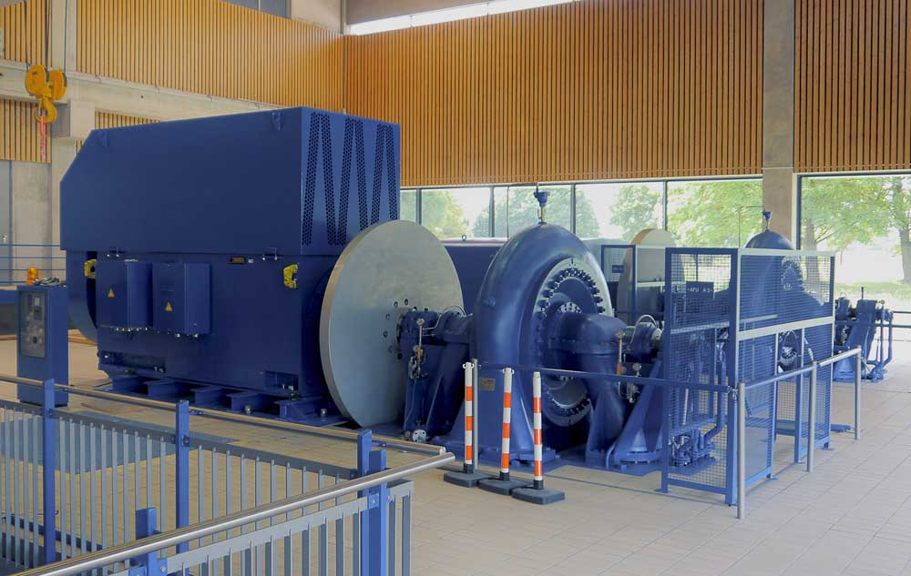
Caption: The Berlin-based manufacturer had a suitable motor in stock and was able to make all adaptations in a very short time

Image/s: | pump_motor_bw_water_supply | Characters: | 1329
File name: | 202005006_pm_pump_water_supply_en | Date: | 06-18-2020
About Menzel Elektromotoren
Based in Berlin, Menzel Elektromotoren GmbH has been manufacturing and distributing electric motors for more than 90 years. The medium-sized company specializes in the delivery of large electric motors, including special models, within the shortest possible time. The product range comprises high and low voltage motors, DC motors, transformers, and frequency inverters. Services include motor production and short-term adaptation of stocked motors to application-specific requirements. In order to ensure fast deliveries to the customer at all times, the company maintains a very extensive inventory including more than 20,000 motors with a maximum performance of up to 15,000 kW. Qualified engineering, experienced staff, and state-of-the-art production and testing facilities help Menzel provide excellent reliability. Menzel operates subsidiaries in the UK, France, Italy, Spain, and Sweden, and cooperates with numerous partners worldwide.

Contact:  Menzel Elektromotoren GmbH  Mathis Menzel  Neues Ufer 19-25  10553 Berlin  Germany  Phone: +49 . 30 . 349 922-0  Email: info@menzel-motors.com  Internet: www.menzel-motors.com | gii die Presse-Agentur GmbH  Immanuelkirchstr. 12  10405 Berlin  Germany  Phone: +49 . 30 . 538 965-0  Email: info@gii.de  Internet: www.gii.de

