Press Release

New RAFI illuminated pushbutton with ring lighting

RAFI has expanded its RAFIX 22 FS⁺ control and signaling units program with illuminated pushbuttons with ring lighting. The pushbuttons come with an illuminated ring in the colors white, red, green, yellow, or blue, which makes them also suitable for night design. The illumination of the ring is provided by an LED. The pushbuttons feature IP65 degree of protection to the front side, an installation height of just 10 mm and, like all RAFIX 22 FS⁺ control and signaling units, they fit standard 22.3 mm installation openings. The pushbuttons deliver clear tactile feedback, even through gloves. For terminal connection, the pushbuttons can be combined with PCB switching elements for PCB application or QC switching elements for conventional wiring. The PCB version has a mounting depth of just 9.2 mm, and the switching elements with LEDs and other components are located on a common board. The QC switching elements are connected individually with 2.8 mm x 0.8 mm quick connectors, resulting in a mounting depth of 27 mm. Illumination is via a plug-in LED clip. Both types of switching elements are available in versions with gold contacts for a maximum 35 V and 100 mA or with silver contacts for up to 250 V and 4 A.
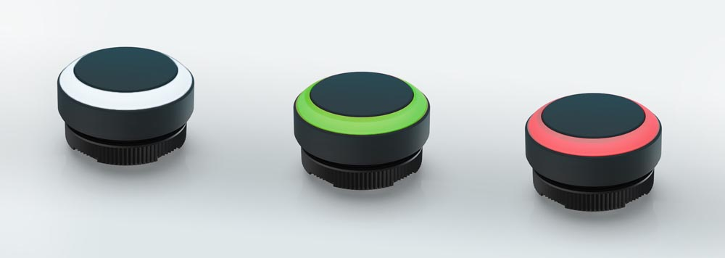
Photo: RAFIX 22 FS+ illuminated pushbutton with ring lighting

Image/s: | RAFIX-22-FS-Taster_Ringausleuchtung | Characters: | 1,222
File name: | 202005026_PM_RAFIX_22_Drucktaster_mit_Ringausleuchtung_en | Date: | 05-27-2020

About the RAFI group
Founded in 1900, RAFI today develops and produces electromechanical components and systems for human-machine interaction. The range of products includes pushbuttons, switches, touchscreens, control systems and electronic assemblies. RAFI products are employed in many industries including automation, medical technology, machine and plant engineering, road and railway vehicles, household appliances and telecommunication. The RAFI group operates internationally with approx. 2,500 employees at sites in Germany, Europe, China and the USA. Its headquarters are in Berg, Germany.

Contact:  RAFI GmbH & Co. KG  Artur Krug  Ravensburger Str. 128-134  88276 Berg, Germany  Phone: +49 751 89-1307  Fax: +49 751 89-1300  Email: artur.krug@rafi.de  Internet: www.rafi.de |  | gii die Presse-Agentur GmbH  Immanuelkirchstr. 12  10405 Berlin, Germany  Phone: +49 30 53 89 65-0  Fax: +49 30 53 89 65-29  Email: info@gii.de  Internet: www.gii.de

