Press Release

New synchronous generator more economic than repair

Menzel Great Britain Ltd has supplied a synchronous generator with a power rating of 11380 kVA to Westfield Power Station in Scotland. The plant operated by the Independent Power Producer (IPP) Melton Renewable Energy UK Ltd had suffered a failure of the existing generator. Purchasing the replacement generator, which was delivered in only two weeks, was significantly more cost-effective than a lengthy repair, as the IPP may incur revenue losses when the power supply is interrupted. It was fortuitous that a synchronous generator of suitable rating and performance class was readily available on the market, as this application and configuration are very rare, and such generators are usually manufactured with long lead times. Menzel Great Britain is a subsidiary of German motor manufacturer Menzel Elektromotoren who maintains a very extensive inventory and is specialized on customized adaptations on short notice and who was therefore well prepared to answer this urgent request.

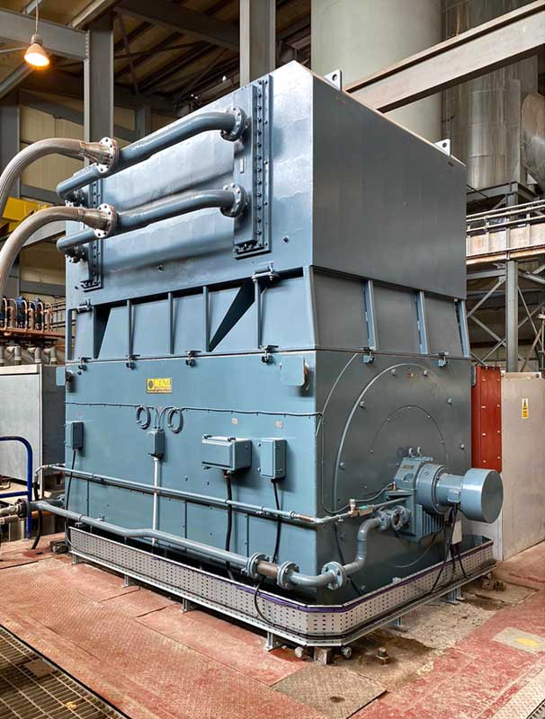
Caption: Menzel Elektromotoren was able to supply a synchronous generator from stock and adapt it for the customer at short notice

The generator is powered by a steam turbine. It operates at 11 kV supply voltage and weighs more than 35 tons. Menzel completed the various customer-specific interface modifications in the short time available. Preparing the shaft to match coupling interfaces was particularly complex, since it had to be shortened, machined for a smaller diameter, and the appropriate flange had to be weld-fitted and subjected to an ultrasound check, which ensured that the modification was sound. In order to match site requirements, Menzel also changed the cooling type of the replacement generator from IC 01 open-circuit ventilated to IC 81W air-water heat exchanger, building an adapter frame and mounting a suitable twin element heat exchanger from existing stock.
Westfield Power Station, which was commissioned in 2000, is the only biomass power plant in Scotland fueled by poultry litter. It is a key partner to the region's agricultural industry both for disposing of a high-volume waste product and as a supplier of power and fertilizer – the nutrient-rich ash produced is a precious natural alternative to artificial fertilizers. The 9.8 MW biomass steam power plant also stands out technologically as it is one of a limited few in the world utilizing fluidized bed technology. The CO₂ savings compared to gas-fired power plants are considerable.
Three-phase synchronous and asynchronous generators for highest efficiencies: https://www.menzel-motors.com/specialized-motors/generators/

Image/s: | synchronous_generator_westfield | Characters: | 2330
File name: | 202007030_pm_synchronous_generator_11mva_en | Date: | 09-01-2020
About Menzel Elektromotoren
Based in Berlin, Menzel Elektromotoren GmbH has been manufacturing and distributing electric motors for more than 90 years. The medium-sized company specializes in the delivery of large electric motors, including special models, within the shortest possible time. The product range comprises high and low voltage motors, DC motors, transformers, and frequency inverters. Services include motor production and short-term adaptation of stocked motors to application-specific requirements. In order to ensure fast deliveries to the customer at all times, the company maintains a very extensive inventory including more than 20,000 motors with a maximum performance of up to 15,000 kW. Qualified engineering, experienced staff, and state-of-the-art production and testing facilities help Menzel provide excellent reliability. Menzel operates subsidiaries in the UK, France, Italy, Spain, and Sweden, and cooperates with numerous partners worldwide.

Contact:  Menzel Elektromotoren GmbH  Mathis Menzel  Neues Ufer 19-25  10553 Berlin  Germany  Phone: +49 . 30 . 349 922-0  Email: info@menzel-motors.com  Internet: www.menzel-motors.com | gii die Presse-Agentur GmbH  Immanuelkirchstr. 12  10405 Berlin  Germany  Phone: +49 . 30 . 538 965-0  Email: info@gii.de  Internet: www.gii.de

