Press Release

Plug & play compressor motor for Tata Steel

Menzel Elektromotoren has customized a motor for a compressor drive operated by Tata Steel, shipping it within just two weeks. A motor failure had stalled the booster air compressor, which is integral to one of the corporation's Indian steelworks, providing oxygen necessary for steel production. Thanks to its modular warehousing strategy, Menzel was able to speedily configure a squirrel-cage motor in accordance with customer specifications. The MEBKSL-type motor was electrically and mechanically adapted to enable installation and commissioning by the customer without further modifications of the motor or the site.

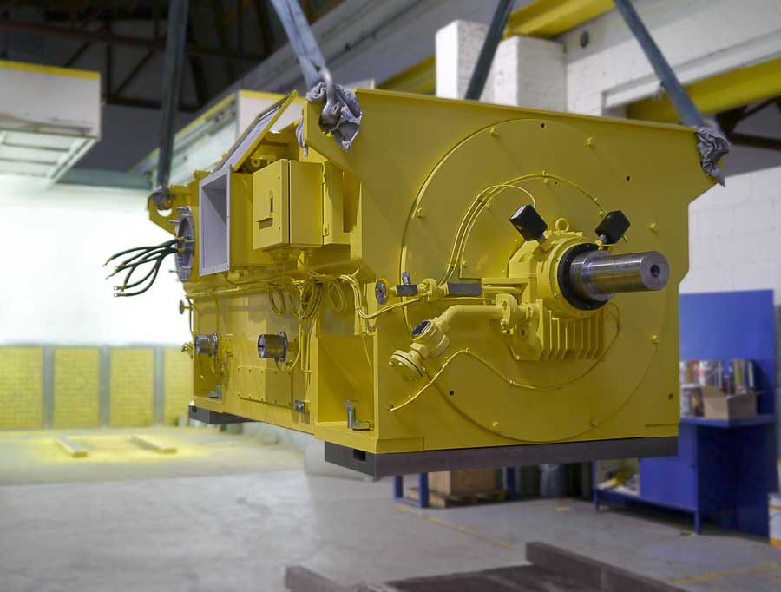
Caption: Menzel's modular motor series enable short-term order-specific configuration in the high power range

The motor with an operating voltage of 6600 V and a rated power of 3200 kW was fitted with an air-to-air heat exchanger (cooling type IC 611). Menzel staff at the Berlin plant shortened the motor shaft, milled the shaft end, and produced intermediate plates to adjust the fixing dimensions to the existing installation site. The 2-pole motor was designed with sleeve bearings with 2-wedge bearing shells to avoid any critical speed in the vicinity of the operating point of 2987 rpm. The motor is also designed for demanding conditions with ambient temperatures up to 50 °C and humidity up to 95%. It features a tropicalized motor winding in temperature class "F" and the increased protection class IP55. Menzel manufactures motors for large industrial compressors in various types and offers several feature options. The company’s large stock includes several series of squirrel-cage and slip ring motors with air or water cooling or open-circuit ventilation, optionally with self-ventilation or forced ventilation, and prepared for inverter operation.
More customer references: https://www.menzel-motors.com/compressor-drive/

Image/s: | compressor_motor_tata_steel | Characters: | 1674
File name: | 202008008_pm_compressor_tata_steel_en | Date: | 09-22-2020
About Menzel Elektromotoren
Based in Berlin, Menzel Elektromotoren GmbH has been manufacturing and distributing electric motors for more than 90 years. The medium-sized company specializes in the delivery of large electric motors, including special models, within the shortest possible time. The product range comprises high and low voltage motors, DC motors, transformers, and frequency inverters. Services include motor production and short-term adaptation of stocked motors to application-specific requirements. In order to ensure fast deliveries to the customer at all times, the company maintains a very extensive inventory including more than 20,000 motors with a maximum performance of up to 15,000 kW. Qualified engineering, experienced staff, and state-of-the-art production and testing facilities help Menzel provide excellent reliability. Menzel operates subsidiaries in the UK, France, Italy, Spain, and Sweden, and cooperates with numerous partners worldwide.

Contact:  Menzel Elektromotoren GmbH  Mathis Menzel  Neues Ufer 19-25  10553 Berlin  Germany  Phone: +49 . 30 . 349 922-0  Email: info@menzel-motors.com  Internet: www.menzel-motors.com | gii die Presse-Agentur GmbH  Immanuelkirchstr. 12  10405 Berlin  Germany  Phone: +49 . 30 . 538 965-0  Email: info@gii.de  Internet: www.gii.de

