Press Release

Backup DC motor for two rolling mill applications

Menzel Elektromotoren has built a replica of an old DC motor for a large German steel strip manufacturer. The new motor was designed as a reserve for two site applications, a roller motor and a coiler drive. This flexible configuration saves the customer money and storage space, whilst protecting the rolling mill against downtime in the event of either existing motor suffering damage. To determine the essential data, Menzel engineers worked closely with the customer, studied the existing motor's documentation, and took additional measurements. Menzel manufactured a special construction with two shaft ends, foot dimensions matching both installation sites, as well as provision for a special encoder including an insulated coupling. The positions of the terminal box and the air inlet opening were adapted to the existing connections on site. The DC motor featuring 450 kW rated power and 530 V rated voltage is also characterized by a high field-weakening range. A family-run, customer-focused business, Menzel fulfills even demanding individual requests. Replicas of old motors are something of a specialty of Menzel's – from electrically and mechanically suitable replacements to exact copies. The current customer is fully satisfied with the DC motor supplied and has already placed a second order.
More about Menzel's expertise in the construction of DC motors: https://www.menzel-motors.com/dc-motors/

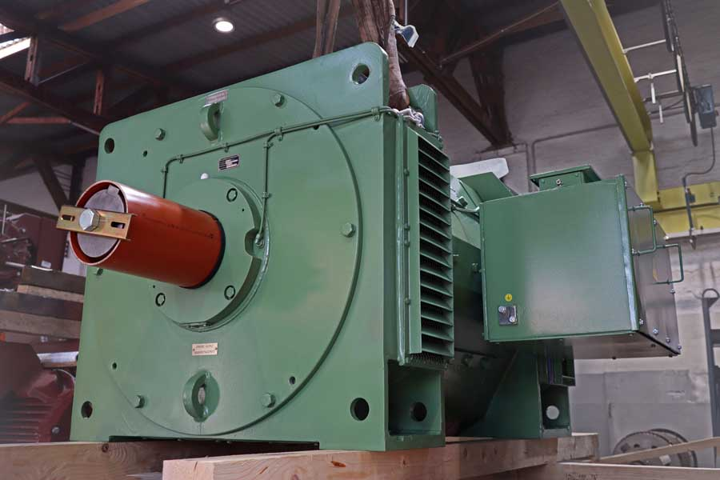
Caption: Menzel modeled the DC motor on an old roller motor, configuring it so it can replace either this motor or a coiler drive in the same rolling mill if necessary

Image/s: | dc_roller_motor | Characters: | 1309
File name: | 202009006_pm_dc_roller_motor_en | Date: | 10-21-2020
About Menzel Elektromotoren
Based in Berlin, Menzel Elektromotoren GmbH has been manufacturing and distributing electric motors for more than 90 years. The medium-sized company specializes in the delivery of large electric motors, including special models, within the shortest possible time. The product range comprises high and low voltage motors, DC motors, transformers, and frequency inverters. Services include motor production and short-term adaptation of stocked motors to application-specific requirements. In order to ensure fast deliveries to the customer at all times, the company maintains a very extensive inventory including more than 20,000 motors with a maximum performance of up to 15,000 kW. Qualified engineering, experienced staff, and state-of-the-art production and testing facilities help Menzel provide excellent reliability. Menzel operates subsidiaries in the UK, France, Italy, Spain, and Sweden, and cooperates with numerous partners worldwide.

Contact:  Menzel Elektromotoren GmbH  Mathis Menzel  Neues Ufer 19-25  10553 Berlin  Germany  Phone: +49 . 30 . 349 922-0  Email: info@menzel-motors.com  Internet: www.menzel-motors.com | gii die Presse-Agentur GmbH  Immanuelkirchstr. 12  10405 Berlin  Germany  Phone: +49 . 30 . 538 965-0  Email: info@gii.de  Internet: www.gii.de

