Press Release

RAFI eCatalog: over 5,000 electro-mechanical components

The RAFI eCatalog is available online at components.rafi.de. The eCatalog presents more than 5,000 electro-mechanical RAFI components divided in the product groups emergency stop, pushbuttons, control components, signal lamps, tactile switches and accessories. The completely updated catalog comes with a new user interface and a whole range of new functions. For example, a product finder makes it easy for customers to find the ideal component by entering the parameters they need. For each product, a menu appears next to the technical data and a download option provides an extensive product description including images and videos. There is also a 3D viewer for looking at the product from all angles. The download area provides the 3D data of the selected product in .stp format for import into CAD systems. Users can also find the declarations of conformity as well as operating manuals, certificates and product leaflets there. A wish list allows customers to send product inquiries and receive answers from RAFI distributors. The RAFI eCatalog is available in English, German, French, Italian and Chinese language and was designed for perfect display on desktops, tablets and smartphones.

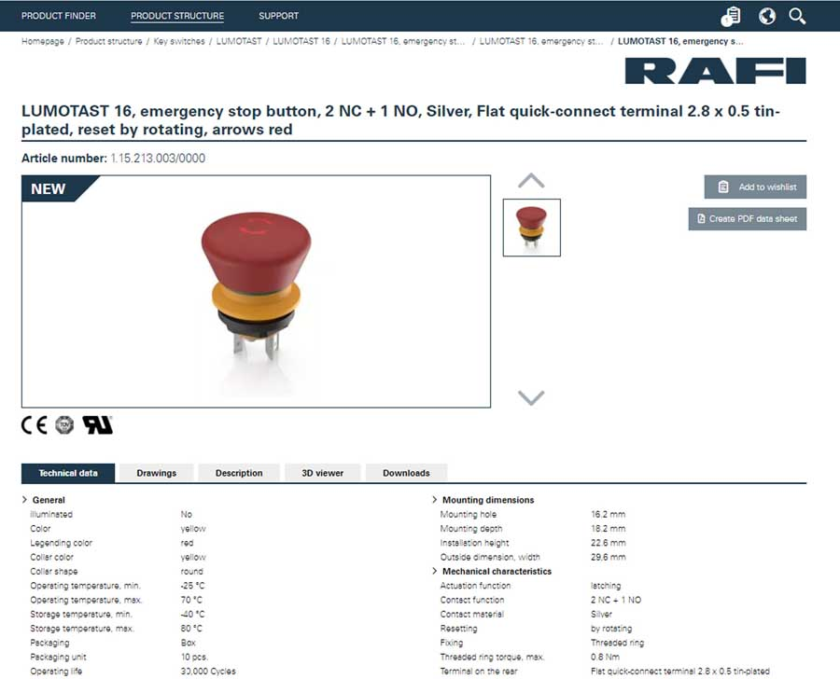
Caption: The RAFI eCatalog is available online (sample screenshot)

Image/s: | RAFI-ecatalog-Screenshot_EN | Characters: | 1197
File name: | 202009021_pm_rafi_ecatalog_en | Date: | 09-09-2020
About the RAFI group
Founded in 1900, RAFI today develops and produces electromechanical components and systems for human–machine interaction. The range of products includes pushbuttons, switches, touchscreens, control systems and electronic assemblies. RAFI products are employed in many industries including automation, medical technology, machine and plant engineering, road and railway vehicles, household appliances and telecommunication. The RAFI group operates internationally with more than 2,000 employees at sites in Germany, Europe, China and the USA. Its headquarters are in Berg, Germany.

Contact:  RAFI GmbH & Co. KG  Artur Krug  Ravensburger Str. 128-134  88276 Berg  Germany  Phone: +49 . 751 . 891 307  Email: artur.krug@rafi.de  Internet: www.rafi.de | gii die Presse-Agentur GmbH  Immanuelkirchstr. 12  10405 Berlin  Germany  Phone: +49 . 30 . 538 9650  Email: info@gii.de  Internet: www.gii.de

