Press Release

RAMO S selector switch comes with its own housing

RAFI’s selector switches in the RAMO S series feature a completely closed housing with IP65 degree of protection and M12 terminals. That means they do not need any additional housing. Therefore, these switches – like all control and indicator elements in the RAMO 22 and 30 series – are ideal for cost-effective construction and retrofitting of decentral applications. Depending on the series, the switches are designed for mounting holes with diameters of 22.3 mm or 30.3 mm.
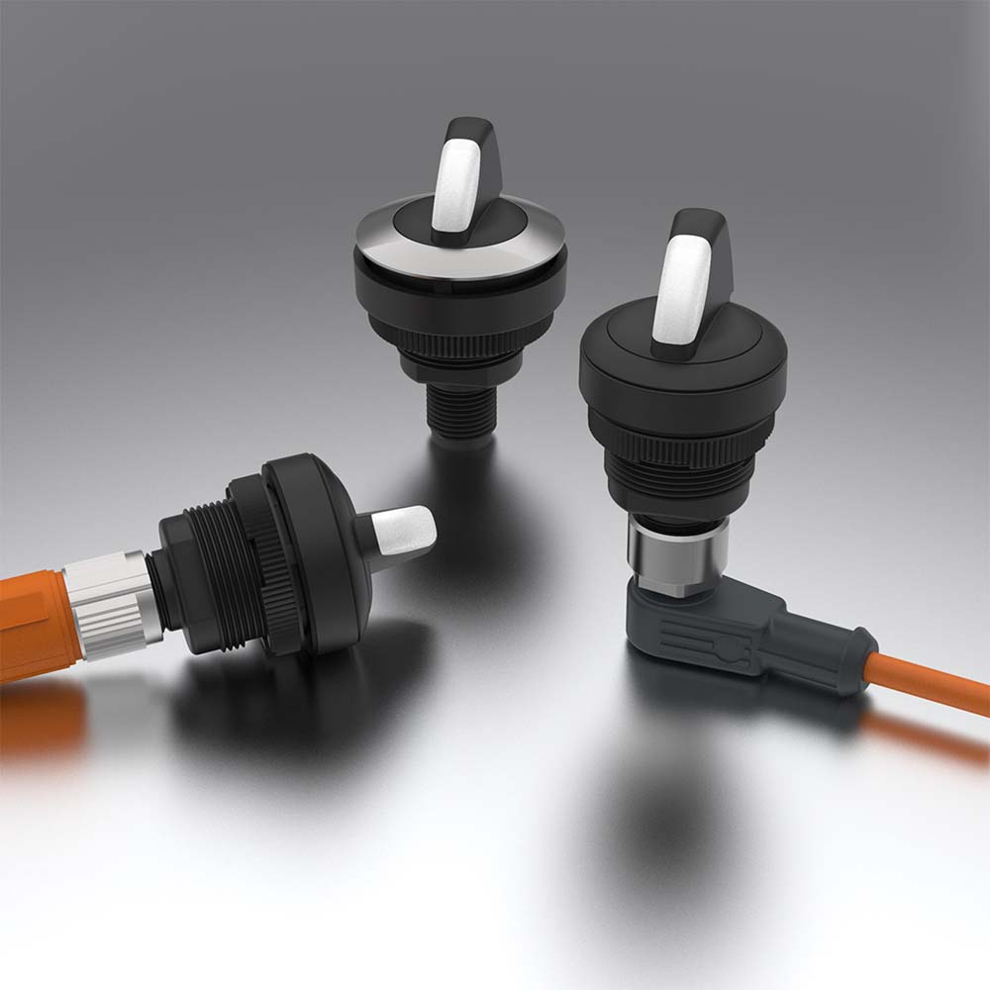
Photo: RAMO S selector switches

Alternatively, the RAMO EDGE fixing angle offers the option of placing the switches offset on any surfaces or on 40-mm profile rails. The RAMO S series comprises selector switches in different types with rotating angles of 40°, 60° or 90°. Depending on the model, the levers can be switched to up to three positions and the actuation functions momentary contact, latching or momentary contact and latching. The contact functions available are 1NC+1NO, 1NO and 2NO. The rugged selector switches are also available in illuminated versions with translucent handle marking. The simple connection with standard M12 plug terminals makes wiring unnecessary, so RAMO switches, key switches and lamps can even be installed by untrained personnel. The components in the RAMO 22 series feature black front rings in synthetic material, while the RAMO 30 versions have flat stainless steel bezels.

Image/s: | RAMO_S | Characters: | 1,362
File name: | 202011005_pm_ramo-s_en | Date: | 11-06-2020

About the RAFI group
Founded in 1900, RAFI today develops and produces electromechanical components and systems for human–machine interaction. The range of products includes pushbuttons, switches, touchscreens, control systems and electronic assemblies. RAFI products are employed in many industries including automation, medical technology, machine and plant engineering, road and railway vehicles, household appliances and telecommunication. The RAFI group operates internationally with 2,000 employees at sites in Germany, Europe, China, and the USA. Its headquarters are in Berg, Germany.
.

Contact:  RAFI GmbH & Co. KG  Artur Krug  Ravensburger Str. 128–134  88276 Berg, Germany  Phone: +49 751 89-1307  Fax: +49 751 89-1300  Email: artur.krug@rafi.de  Internet: www.rafi.de |  | gii die Presse-Agentur GmbH  Immanuelkirchstr. 12  10405 Berlin, Germany  Phone: +49 30 53 89 65-0  Fax: +49 30 53 89 65-29  Email: info@gii.de  Internet: www.gii.de

