Press Release

Compressor motor rush job secures oxygen supply

Working under high pressure, Menzel Elektromotoren completed two much-needed compressor motors and delivered them in just two weeks at the turn of the year, despite a company holiday from Christmas to the New Year. An order from Bangladesh was to ensure the supply of medical oxygen, which gave added urgency during the current pandemic. A Spanish gas manufacturer needed to replace a failed motor quickly to minimize production downtime and revenue loss. Menzel was able to provide high-voltage motors with outputs of 3000 kW and 5200 kW as well as coolers from its extensive stock. All necessary interface modifications were carried out in-house in the short time available, including the conversion from air-to-air to air-to-water cooling IC 81W, machining the shaft end, installing a support and flange for an oil pump, converting the terminal boxes, and boring new foot holes. Special technical expertise was required to secure the oxygen supply even in the event of grid fluctuations; Menzel's technical department and the start-up transformer manufacturer together calculated the ramp-up to ensure that the new motor was compatible with the existing starter. Both orders came from existing customers and were executed to their full satisfaction. Further reference projects for compressor motors can be viewed at: https://www.menzel-motors.com/compressor-drive/.

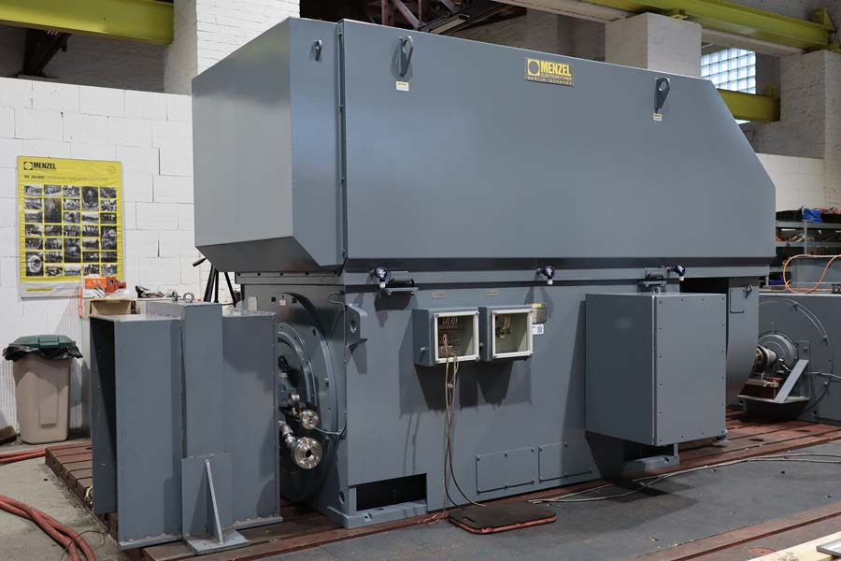
Caption: Menzel adapted the motors to the electrical and mechanical requirements and finally tested them in the in-house test field

Image/s: | compressor_motor_o2_bangladesh | Characters: | 1368
File name: | 202102020_pm_express_compressor_motor_en | Date: | 02-10-2021
About Menzel Elektromotoren
Based in Berlin, Menzel Elektromotoren GmbH has been manufacturing and distributing electric motors for more than 90 years. The medium-sized company specializes in the delivery of large electric motors, including special models, within the shortest possible time. The product range comprises high and low voltage motors, DC motors, transformers, and frequency inverters. Services include motor production and short-term adaptation of stocked motors to application-specific requirements. In order to ensure fast deliveries to the customer at all times, the company maintains a very extensive inventory including more than 20,000 motors with a maximum performance of up to 15,000 kW. Qualified engineering, experienced staff, and state-of-the-art production and testing facilities help Menzel provide excellent reliability. Menzel operates subsidiaries in the UK, France, Italy, Spain, and Sweden, and cooperates with numerous partners worldwide.

Contact:  Menzel Elektromotoren GmbH  Mathis Menzel  Neues Ufer 19-25  10553 Berlin  Germany  Phone: +49 . 30 . 349 922-0  Email: info@menzel-motors.com  Internet: www.menzel-motors.com | gii die Presse-Agentur GmbH  Immanuelkirchstr. 12  10405 Berlin  Germany  Phone: +49 . 30 . 538 965-0  Email: info@gii.de  Internet: www.gii.de

