Press Release

“POWER” now followed by “ULTIMATE”: New High-End ECU for Touchscreens

RAFI uses its own standard ECUs in customer-specific touchscreens and control panels. This has allowed us to quickly realize a large number of projects for industry, agricultural and construction machinery, or medical technology to date, while saving resources. RAFI develops and produces the ECUs and touchscreens including sensors in-house, enabling it to ensure continuous long-term availability and quality of the systems.
RAFI covers a wide range of applications with its ECU program. The RAFI control unit in the “ECO-ECU” series with ARM Cortex-A5 or M3M4 processor was developed for simple, cost-sensitive operating and display tasks, with max. 800 x 600 pixel resolution. Control units in the “BALANCE-ECU” model range with a single ARM Cortex-A9 processor cater for higher operating requirements and resolutions of up to 1920 x 1080 pixels. The even more powerful “POWER-ECUs” with ARM Cortex-A9 in Dual or Quad design are used for touch user interfaces with animated graphics and resolutions of up to 1920 x 1200 pixels.
With the newest “ULTIMATE-ECU” series, RAFI is raising its range of Embedded Control Units to the next performance level. The “ULTIMATE-ECU” is designed for touchscreen applications with high quality 3D visualization, multi-touch inputs, and Full-HD screen resolutions on up to 24"' display diagonals. Its centerpiece is an ARM Cortex-A35, i.MX8QuadXPlus processor from NXP with Yocto-based embedded Linux core and a clock frequency of 900 MHz. As standard, the “ULTIMATE ECU” offers two Gigabit-Ethernet interfaces, a USB 3.0 interface and three CAN-Bus interfaces. The new ECU generation has already been proving its worth as a central computer for mobile processing machines in several projects.

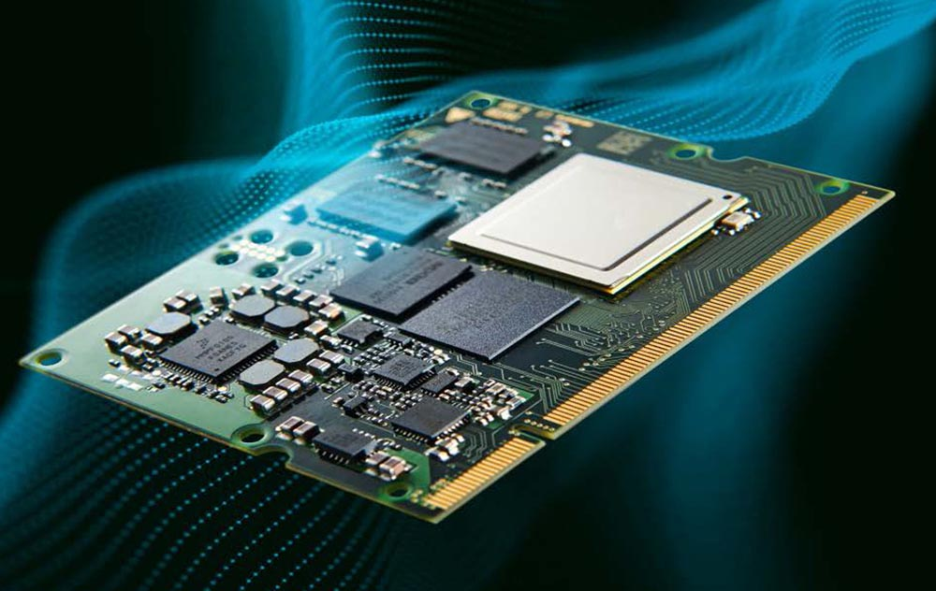
Caption: RAFI standard ECU for customer-specific, high-end operating solutions

Image/s: | RAFI-Standard-ECU | Characters: | 1,731
File name: | 202102029_pm_ULTIMATE-Power-ECU | Date: | 03-04-2021
About the RAFI group
Founded in 1900, RAFI today develops and produces electromechanical components and systems for human–machine interaction. The range of products includes pushbuttons, switches, touchscreens, control systems and electronic assemblies. RAFI products are employed in many industries including automation, medical technology, machine and plant engineering, road and railway vehicles, household appliances and telecommunication. The RAFI group operates internationally with 2,000 employees at sites in Germany, Europe, China, and the USA. Its headquarters are in Berg, Germany.

Contact:  RAFI GmbH & Co. KG  Artur Krug  Ravensburger Str. 128–134  88276 Berg, Germany  Phone: +49 751 89-1307  Fax: +49 751 89-1300  Email: artur.krug@rafi.de  Internet: www.rafi.de |  | gii die Presse-Agentur GmbH  Immanuelkirchstr. 12  10405 Berlin  Phone: +49 30 53 89 65-0  Fax: +49 30 53 89 65-29  Email: info@gii.de  Internet: www.gii.de

