Press Release

Protective camera enclosure for Intel® RealSense™ D455

autoVimation expands its Chameleon XS enclosure series for the Intel® RealSense™ Depth Camera family, adding a new enclosure for the D455 camera. The 500g lightweight aluminum enclosure provides reliable IP66/67 ingress protection all-around, allowing the depth cameras to be employed in unmanned aerial vehicles, in outdoor vision applications, and in challenging industrial environments. The outer dimensions are 150 mm x 64 mm x 34 mm. Like the existing Chameleon XS enclosures for the RealSense sensors D415, D435, and T265, the D455 model ensures shade-free images thanks to the special arrangement of the windows. The windows are made of anti-reflective BK7 glass. To compensate for thermal expansion and vibrations, they are fitted into the housing openings with special seals instead of being glued. Under normal conditions, cooling is not required because the camera is connected with a solid aluminum adapter and a double-layer thermal film for heat coupling with the enclosure. A cable gland with an extra-large sealing inlay enables tool-free entry of standard cables with USB-C plugs. With the help of a dovetail adapter plate, the Chameleon XS enclosures are fully compatible to autoVimation’s machine vision construction kit. This way, all 30mm dovetail mounting kits can be used to mount and align the housing vibration-proof on flat surfaces or slot profiles.

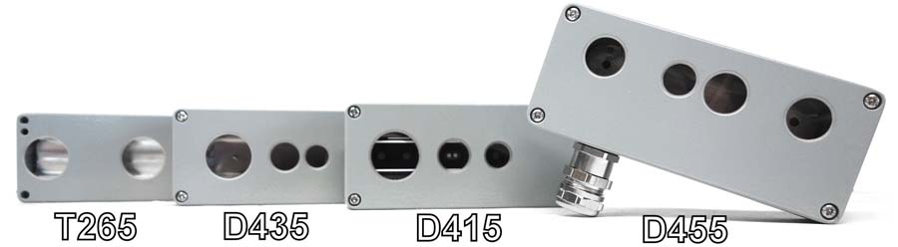
Caption: The Chameleon XS enclosure series now also provides IP66/67 protection for the Intel® RealSense™ Depth Camera D455

Image/s: | 4_x_chamaeleon-xs | Characters: | 1376
File name: | 202103013_pm_chameleon_xs_d455_en | Date: | 03-04-2021
About autoVimation
Established in 2008, Karlsruhe-based autoVimation was founded by Peter Neuhaus to provide solutions for easier installation and adjustment of image processing components. The company has developed a modular construction kit that simplifies the connection of all required components, which does away with costly and time-consuming manufacturing of dedicated mounting brackets. The product portfolio also includes compact, easy-to-integrate enclosures that provide optimal protection for cameras and lenses in industrial applications, and ensure good heat dissipation. autoVimation supplies complete, ready-to-install mechanical solutions for cameras and light fittings, and enables the integration of special lenses, filters, light barriers, encoders, or other sensors.
autoVimation's customers include renowned companies from various industry branches, such as the pharmaceutical and food industry, measuring technology, quality control, and security technology.

Contact:  autoVimation GmbH  Peter Neuhaus  Roemerweg 1  76287 Rheinstetten  Germany  Phone: +49 . 721 . 627 6756  Email: sales@autovimation.com  Internet: www.autovimation.com | gii die Presse-Agentur GmbH  Immanuelkirchstr. 12  10405 Berlin  Germany  Phone: +49 . 30 . 538 9650  Email: info@gii.de  Internet: www.gii.de

