Press Release

Asynchronous generator with special shaft for Pelton wheel

Menzel Elektromotoren has built an asynchronous generator with a special shaft and a special flange for operation on a Pelton wheel in a Scandinavian hydroelectric power plant. The large radial forces acting on the shaft end in this application had damaged the existing generator to the extent that it was a total write-off. The customer required a more robust shaft construction to avoid such damage in the future. In addition, the new generator had to be identical to the old one and have the same electrical parameters. Menzel’s subsidiary Franz Wölfer Elektromaschinenfabrik designed and manufactured a shaft made of 42CrMo4 high-tensile strength special steel, reinforced on the turbine side. The concentrated collaborative expertise within the Menzel Group made it possible to quickly prepare a verified offer and complete the generator within two and a half weeks. Menzel could deliver fast thanks to clever warehousing: a prefabricated three-phase asynchronous generator met the requirements of the application in the hydroelectric power plant. Menzel merely designed and manufactured a new bearing shield for the reinforced shaft and bearing. This generator order came in through Menzel’s Swedish subsidiary, which, like numerous offices and partners around the world, provides customer-oriented advice and service.
More about asynchronous and synchronous motors: https://www.menzel-motors.com/specialized-motors/generators/

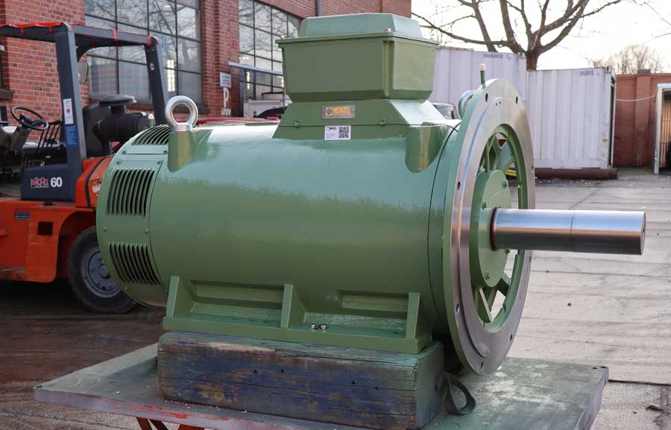
Caption: Menzel built the generator with a special shaft to withstand the large radial forces in the Pelton wheel application

Image/s: | asynch_generator_pelton_wheel | Characters: | 1324
File name: | 202103014_pm_generator_pelton_wheel_en | Date: | 03-04-2021
About Menzel Elektromotoren
Based in Berlin, Menzel Elektromotoren GmbH has been manufacturing and distributing electric motors for more than 90 years. The medium-sized company specializes in the delivery of large electric motors, including special models, within the shortest possible time. The product range comprises high and low voltage motors, DC motors, transformers, and frequency inverters. Services include motor production and short-term adaptation of stocked motors to application-specific requirements. In order to ensure fast deliveries to the customer at all times, the company maintains a very extensive inventory including more than 20,000 motors with a maximum performance of up to 15,000 kW. Qualified engineering, experienced staff, and state-of-the-art production and testing facilities help Menzel provide excellent reliability. Menzel operates subsidiaries in the UK, France, Italy, Spain, and Sweden, and cooperates with numerous partners worldwide.

Contact:  Menzel Elektromotoren GmbH  Mathis Menzel  Neues Ufer 19-25  10553 Berlin  Germany  Phone: +49 . 30 . 349 922-0  Email: info@menzel-motors.com  Internet: www.menzel-motors.com | gii die Presse-Agentur GmbH  Immanuelkirchstr. 12  10405 Berlin  Germany  Phone: +49 . 30 . 538 965-0  Email: info@gii.de  Internet: www.gii.de

