Press Release

RAFI Manager Tosberg re-elected as COGD Board Member

Joachim Tosberg, Life Cycle Manager at RAFI, has been re-elected for the second time as a Board Member of the Component Obsolescence Group Deutschland (COGD). Since 2017, RAFI has been a member of the association, which currently comprises more than 160 companies, and is working there on recommendations for action and guidelines for best-practice solutions in dealing with obsolescence. “The current focus is increasingly on the topic of sustainability”, explains Tosberg. “With the SCIP database, the EU has further tightened the requirements according to RoHS and REACH, obliging manufacturers to report the use of substances of concern in a Europe-wide database. This not only concerns electronic components, but also synthetic materials, metals, paints, and much more. It is therefore all the more important to counteract the accelerated discontinuation of components and materials through proactive selection of the most durable, permanently available materials and components possible. Through our involvement in the COGD, we can help shape the conditions and structures for sustainable obsolescence management in association with other industry players and make product development more resource-efficient overall.” One of the key tasks of COGD, which leading industrial companies as well as numerous component manufacturers and distributors belong to, is to develop strategies and methods for proactive obsolescence management to be able to adapt products and production processes at an early stage where there are discontinued components and make alternatives available. Apart from exchanging information in seminars, workshops and lectures, the association is also involved in standardizing obsolescence management and has introduced Smart-PCN, an overarching standard for the communication and automatic processing of product discontinuations.

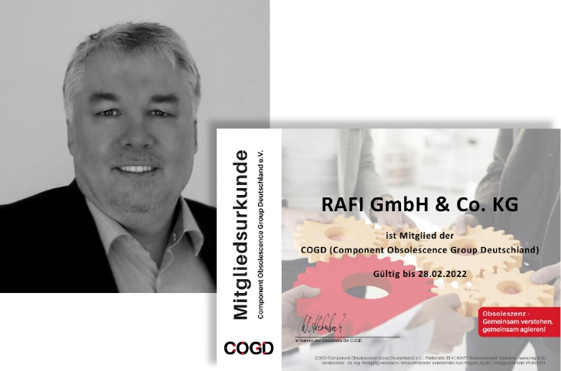

Image: RAFI Manager Joachim Tosberg has been re-elected in 2021 to the Board of the Component Obsolescence Group Deutschland (COGD)

Image/s: | 2021_cogd_vorstand | Characters: | 1,898
File name: | 202107010_pm_rafi_cogd-wiederwahl.docx | Date: | 08-25-2021
About the RAFI group
Founded in 1900, RAFI today develops and produces electromechanical components and systems for human–machine interaction. The range of products includes key switches, switches, touchscreens, control systems and electronic assemblies. RAFI products are employed in many industries including automation, medical technology, machine and plant engineering, road and railway vehicles, household appliances and telecommunication. The RAFI group operates internationally with 2,000 employees at sites in Germany, Europe, China, and the USA. Its headquarters are in Berg, Germany.

Contact:  RAFI GmbH & Co. KG  Artur Krug  Ravensburger Str. 128–134  88276 Berg, Germany  Phone: +49 751 89-1307  Email: artur.krug@rafi-group.com  Internet: www.rafi-group.com |  | gii die Presse-Agentur GmbH  Immanuelkirchstr. 12  10405 Berlin, Germany  Phone: +49 30 53 89 65-0  Email: info@gii.de  Internet: www.gii.de

