Press Release

Motor replicas with two shaft ends

Menzel Elektromotoren built two bespoke slip ring motors to drive the mills in a cement plant in the Middle East: replicas of the original motors, each with two shaft ends and precisely fitting all existing interfaces. One shaft end is coupled to the respective cement mill via a gearbox, while the second shaft end connects to an auxiliary drive that is used to position the rotor during maintenance work. Menzel’s motor design ensures full mechanical and electrical compatibility with the failed previously installed machines of Japanese make. The original manufacturer no longer offers this design, which features relatively unusual dimensions. The 6-pole AC motors with a rated power of 2400 kW and a rated voltage of 6600 kV are in accordance with the IEC / EN 60034-1 standard. The carefully replicated design included, among other things, fitting the motors with sleeve bearings. In addition, the German manufacturer designed the motors for double-pipe ventilation (IP23/IC37, previously: IPR44). This cooling type in particular required the motors to exactly match the in-situ parameters. The very short total length of the motors is determined by fixed couplings on both ends. In order to meet this requirement, Menzel positioned the slip ring chamber not externally but between the bearing seats.
More information about tailor-made replicas as well as exact copies of existing motors: https://www.menzel-motors.com/replacement/

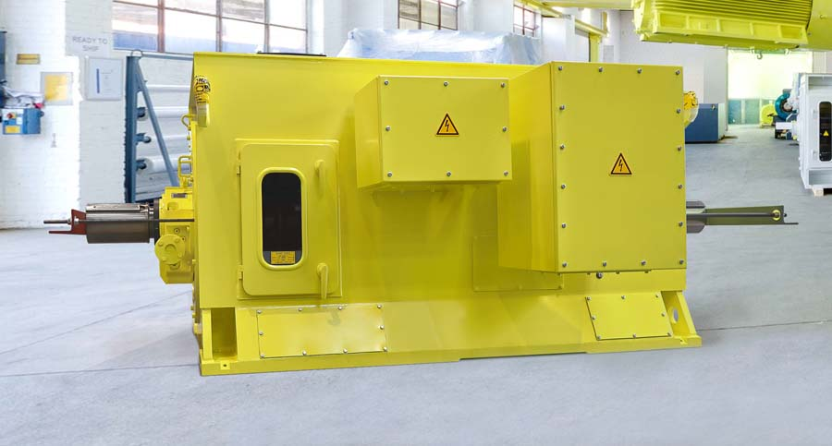
Caption: Menzel Elektromotoren precisely tailored two slip ring motors for cement mills in the Middle East

Image/s: | cement_mill_motor_2_shaft_ends | Characters: | 1306
File name: | 202107013_pm_cement_motor_2_shaft_ends_en | Date: | 08-04-2021
About Menzel Elektromotoren
Based in Berlin, Menzel Elektromotoren GmbH has been manufacturing and distributing electric motors for more than 90 years. The medium-sized company specializes in the delivery of large electric motors, including special models, within the shortest possible time. The product range comprises high and low voltage motors, DC motors, transformers, and frequency inverters. Services include motor production and short-term adaptation of stocked motors to application-specific requirements. In order to ensure fast deliveries to the customer at all times, the company maintains a very extensive inventory including more than 20,000 motors with a maximum performance of up to 15,000 kW. Qualified engineering, experienced staff, and state-of-the-art production and testing facilities help Menzel provide excellent reliability. Menzel operates subsidiaries in the UK, France, Italy, Spain, and Sweden, and cooperates with numerous partners worldwide.

Contact:  Menzel Elektromotoren GmbH  Mathis Menzel  Neues Ufer 19-25  10553 Berlin  Germany  Phone: +49 . 30 . 349 922-0  Email: info@menzel-motors.com  Internet: www.menzel-motors.com | gii die Presse-Agentur GmbH  Immanuelkirchstr. 12  10405 Berlin  Germany  Phone: +49 . 30 . 538 965-0  Email: info@gii.de  Internet: www.gii.de

