Press Release

Pump motor with special flange for chemical plant

Menzel Elektromotoren has realized an unusual motor configuration to help out a customer: the operator of a large chemical plant needed a replacement for a failed pump motor. It seemed difficult, at first, to find a machine able to accommodate an existing oversized pump flange dimension. Only the family-run company Menzel offered a size 400 motor that matched the performance profile and was light enough. The Berlin-based manufacturer converted a stock, IM B3 type motor (foot mounting) to type IM V1 (vertical flange mounting). For this purpose, the drive-end bearing seat was converted for the installation of a thrust bearing. Menzel also manufactured the special flange in-house and adapted it to the shaft, which could only protrude 120 mm from the flange. Menzel prepared the motor for quick installation at the customer’s site, shifting the main terminal box to the most accessible position and mounting a cable entry that could be readily adapted to the existing cable diameter on site. By installing both the heater and PT100 connections in one auxiliary terminal box, Menzel was able to save one terminal box. The motor, which is now successfully in operation in the customer’s plant, has a rated output of 315 kW and a nominal voltage of 5000 V. It features the cooling type IC 411 and an IP55 protection rating and weighs 4900 kg.
More information about squirrel-cage motors with cooling type IC 411 is available at https://www.menzel-motors.com/squirrel-cage-motor/ic411-ic416/.

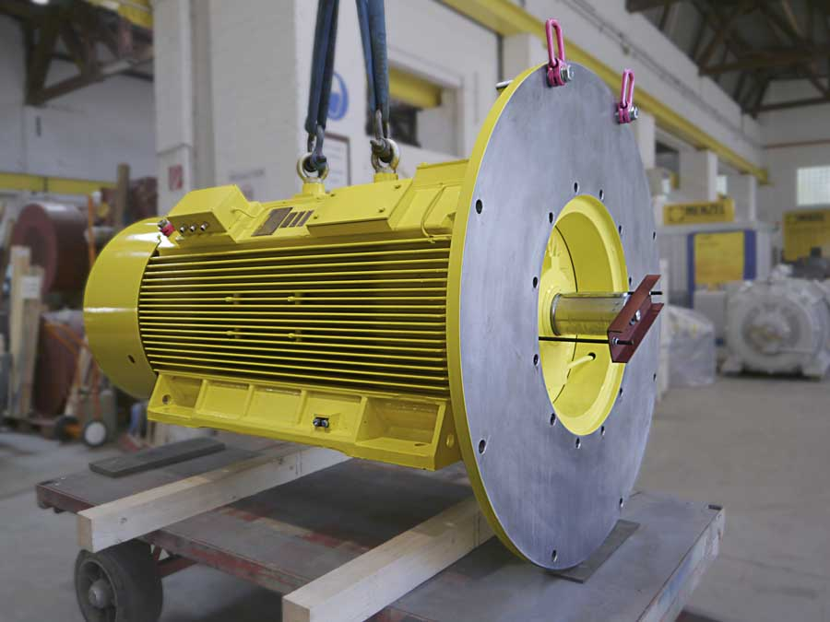
Caption: Menzel had a suitable motor in stock and made all necessary modifications for this pump application within a short time, including a special oversized flange for vertical mounting

Image/s: | menzel_pump_motor_special_flange |  | Characters: | 1493
File name: | 202108020_pm_pump_motor_chem_plant_en |  | Date: | 09-01-2021
About Menzel Elektromotoren
Based in Berlin, Menzel Elektromotoren GmbH has been manufacturing and distributing electric motors since 1927. The medium-sized company specializes in the delivery of large electric motors, including special models, within the shortest possible time. The product range comprises high and low voltage motors, DC motors, transformers, and frequency inverters. Services include motor production and short-term adaptation of stocked motors to application-specific requirements. In order to ensure fast deliveries to the customer at all times, the company maintains a very extensive inventory including more than 20,000 motors with a maximum performance of up to 15,000 kW. Qualified engineering, experienced staff, and state-of-the-art production and testing facilities help Menzel provide excellent reliability. Menzel operates subsidiaries in the UK, France, Italy, Spain, and Sweden, and cooperates with numerous partners worldwide.
Contact:  Menzel Elektromotoren GmbH  Mathis Menzel  Neues Ufer 19-25  10553 Berlin  Germany  Phone: +49 . 30 . 349 922-0  Email: info@menzel-motors.com  Internet: www.menzel-motors.com |  | gii die Presse-Agentur GmbH  Immanuelkirchstr. 12  10405 Berlin  Germany  Phone: +49 . 30 . 538 965-0  Email: info@gii.de  Internet: www.gii.de

