Press Release

E²MS for low-power applications

Today, the energy consumption of heating radiators is usually recorded and calculated fully automatically using smart meters. These devices must function maintenance-free and without battery replacement over an operating life of ten years. As a provider of electronic engineering and manufacturing services (E²MS), RAFI produces large quantities of these high-value electronic meters and additionally supports metering companies in optimizing designs for low-power applications. To ensure its customers can rely on the maintenance-free functioning of its devices, RAFI insists on appropriately long storage and supply periods. This is why the E²MS service provider exclusively procures its lithium batteries for low-power applications from suppliers who guarantee an extended minimum service life of 12.5 years. RAFI additionally carries out in-house random checks of the battery cells. All handling and manufacturing processes are designed to avoid wear-inducing stress on the batteries. Apart from battery quality, the energy-saving function is crucial for the service life of low-power electronic devices. RAFI recommends energy-efficient components and optimizes PCB layouts and intended transmission performance. Engineering solutions and high manufacturing quality prevent leakage currents. To protect against electromagnetic interference, RAFI takes suitable EMC precautions, if necessary including shielding.

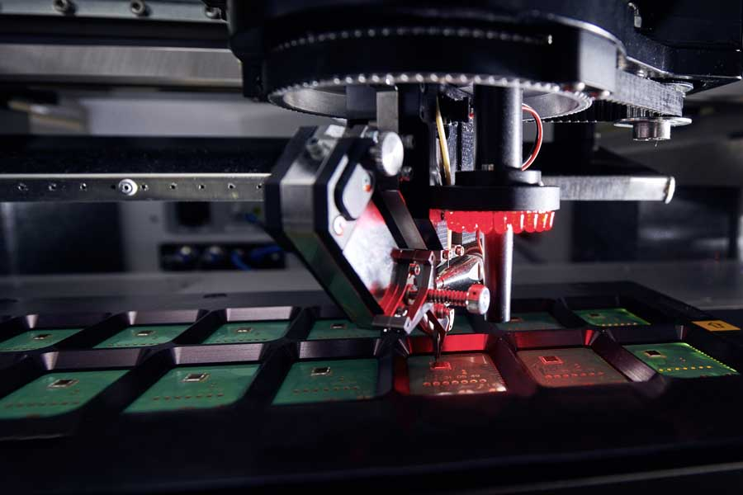
Caption: As a provider of electronic engineering and manufacturing services (E²MS), RAFI supports its customers with the design and manufacture of low-power, maintenance-free electronics

 | Image/s: | rafi_eltec_cob_wirebonden_13plus |  | Characters: | 1416
 | File name: | 202109019_pm_rafi_ems_low-power_appl_en |  | Date: | 09-16-2021
About the RAFI group
Founded in 1900, RAFI today develops and produces electromechanical components and systems for human–machine interaction. The range of products includes pushbuttons, switches, touchscreens, control systems and electronic assemblies. RAFI products are employed in many industries including automation, medical technology, machine and plant engineering, road and railway vehicles, household appliances and telecommunication. The RAFI group operates internationally with more than 2,000 employees at sites in Germany, Europe, China and the USA. Its headquarters are in Berg, Germany.
Contact:

RAFI GmbH & Co. KG
Artur Krug
Ravensburger Str. 128-134
88276 Berg
Germany
Phone: +49 . 751 . 891 307
Email: artur.krug@rafi-group.com
Internet: www.rafi-group.com

