Press Release

TÜV attestation for IP67 motors

Menzel Elektromotoren manufactures IP67 low and medium voltage squirrel-cage motors up to size 355. TÜV Süd has recently attested the dust- and waterproof construction according to protection class IP67 of an entire low voltage motor type series. The series extends to outputs of 400 kW and voltages of 1000 V. In addition, TÜV Süd has attested Menzel’s procedures for IP67 testing, which the manufacturer also offers for medium voltage motors from its own brand up to 11 kV. Menzel builds IP67 motors with minimal tolerances, waterproof encapsulated cast-iron casings and terminal boxes. The manufacturer holds stock in its main warehouse of all basic components for dust- and waterproof squirrel-cage motors and can therefore realize very short delivery times for standard designs of IP67 motors. The motors are used worldwide, mainly in pump stations, flood-prone areas, food and drink industries and maritime applications. They can be fully immersed at standstill for a period of 24 hours without any ingress of water. Subsequently, when water has receded, the motors are ready to be switched on again directly. The manufacturer runs comprehensive acceptance tests on its motors in its inhouse load test field before shipping. As part of the test spectrum, Menzel also offers underwater tests for all induction motors with cage or slip ring rotors.
At the 2021 AEMT Awards of the Association of Electrical and Mechanical Trades, Menzel IP67 motors were voted the Product of the Year.
Product page: https://www.menzel-motors.com/ip67-motor/

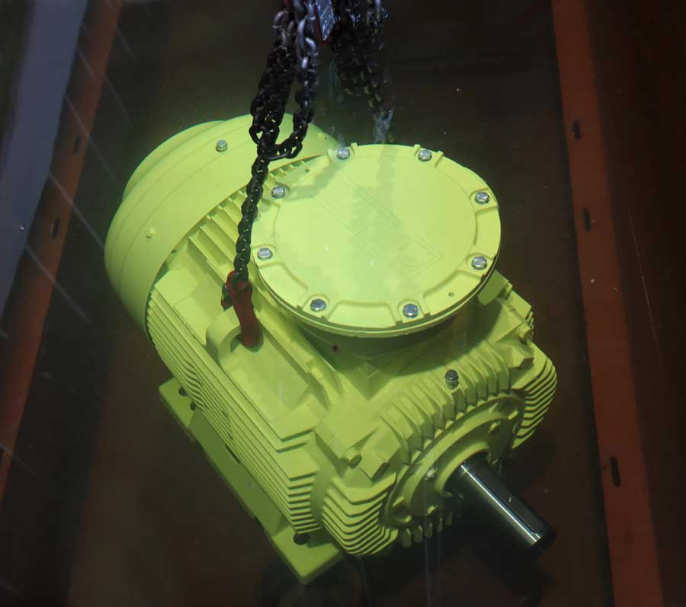
Caption: Menzel’s IP67 motor series and inhouse IP67 testing are verified by TÜV Süd

Image/s: | menzel_ipx7_motor_test | Characters: | 1486
File name: | 2022-06-11_2_tuev_attestation_ip67_en | Date: | 06-10-2022
About Menzel Elektromotoren
Based in Berlin, Menzel Elektromotoren GmbH has been manufacturing and distributing electric motors since 1927. The medium-sized company specializes in the delivery of large electric motors, including special models, within the shortest possible time. The product range comprises high and low voltage motors, DC motors, transformers, and frequency inverters. Services include motor production and short-term adaptation of stocked motors to application-specific requirements. In order to ensure fast deliveries to the customer at all times, the company maintains a very extensive inventory including more than 20,000 motors with a maximum performance of up to 15,000 kW. Qualified engineering, experienced staff, and state-of-the-art production and testing facilities help Menzel provide excellent reliability. Menzel operates subsidiaries in the UK, France, Italy, Spain, and Sweden, and cooperates with numerous partners worldwide.
Contact:  Menzel Elektromotoren GmbH  Mathis Menzel  Neues Ufer 19 – 25  10553 Berlin  Germany  Phone: +49 . 30 . 349 922-0  Email: info@menzel-motors.com  Internet: www.menzel-motors.com |  | gii die Presse-Agentur GmbH  Immanuelkirchstr. 12  10405 Berlin  Germany  Phone: +49 . 30 . 538 9650  Email: info@gii.de  Internet: www.gii.de

