Press Release

Spare motor for four sugar plants

Menzel Elektromotoren has configured a flexible spare motor for one of Europe’s leading sugar producers, which can replace motors of various other makes if necessary. While the customer can basically employ the three-phase squirrel cage motor in any of its plants around the world, it is in fact specifically designed for the sugar beet pulp dryers in four plants in Germany and Sweden. With a rated output of 1400 kW, it covers the drive power requirements of four separate systems, which range from 1000 kW to 1400 kW. It is designed as a vertical motor for flange mounting (IM V1 standing or IM V3 suspended). In addition, an adapter also manufactured by Menzel enables foot mounting in a system with a V2 flange. The motor with cooling type IC 616 meets the protection class IP55. The customer was on site for acceptance testing at Menzel’s Berlin plant. More and more large organizations are looking to utilize spare assets over multiple processes and Menzel is the go-to supplier in this niche market. The modular MEBKSL motor series enables a variety of cooling types and ingress protection ratings as well as various mounting options at optimized production costs. The tried-and-tested design meets high standards in terms of size, performance, cost-effectiveness and reliability.
More about three-phase asynchronous motors with squirrel cage rotors: https://www.menzel-motors.com/squirrel-cage-motor/

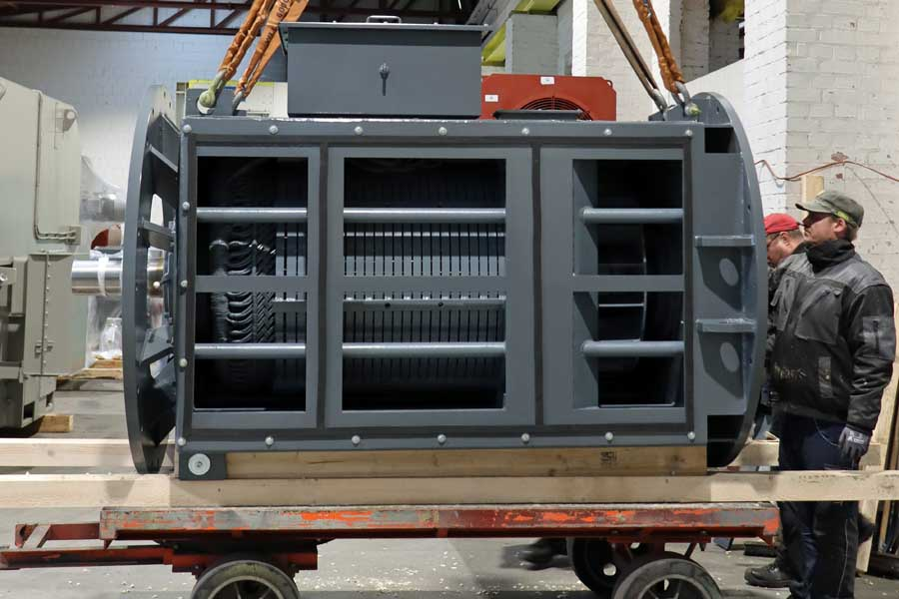
Caption: The flexibly designed spare can replace either of four beet pulp dryer motors in various sugar plants

Image/s: | joker_motor_sugar_plants | Characters: | 1288
File name: | 2022-06-11_3_joker_motor_sugar_plants_en | Date: | 06-10-2022
About Menzel Elektromotoren
Based in Berlin, Menzel Elektromotoren GmbH has been manufacturing and distributing electric motors since 1927. The medium-sized company specializes in the delivery of large electric motors, including special models, within the shortest possible time. The product range comprises high and low voltage motors, DC motors, transformers, and frequency inverters. Services include motor production and short-term adaptation of stocked motors to application-specific requirements. In order to ensure fast deliveries to the customer at all times, the company maintains a very extensive inventory including more than 20,000 motors with a maximum performance of up to 15,000 kW. Qualified engineering, experienced staff, and state-of-the-art production and testing facilities help Menzel provide excellent reliability. Menzel operates subsidiaries in the UK, France, Italy, Spain, and Sweden, and cooperates with numerous partners worldwide.
Contact:  Menzel Elektromotoren GmbH  Mathis Menzel  Neues Ufer 19 – 25  10553 Berlin  Germany  Phone: +49 . 30 . 349 922-0  Email: info@menzel-motors.com  Internet: www.menzel-motors.com |  | gii die Presse-Agentur GmbH  Immanuelkirchstr. 12  10405 Berlin  Germany  Phone: +49 . 30 . 538 9650  Email: info@gii.de  Internet: www.gii.de

