Press Release

New motor plant for Menzel Elektromotoren

Menzel Elektromotoren has signed the construction contract for a new, larger motor plant in Hennigsdorf, near Berlin. The manufacturer has experienced substantial growth in recent years and has outgrown its present headquarters in central Berlin. “Our new location will feature state-of-the-art machinery, efficient logistics, larger hoist capacities for optimized production processes and high energy efficiency,” says CEO Mathis Menzel on the occasion of the signing of the contract. “We will also expand our team and create around 100 new jobs in production and administration in the medium term.” The new site offers optimal conditions for this: a gross floor area of around 8500 m² will accommodate a motor plant with production, testing and storage areas as well as offices. The extensive plot allows for flexible expansions to meet future growth requirements. Construction is to start in the summer, with final acceptance scheduled for August, 2023.

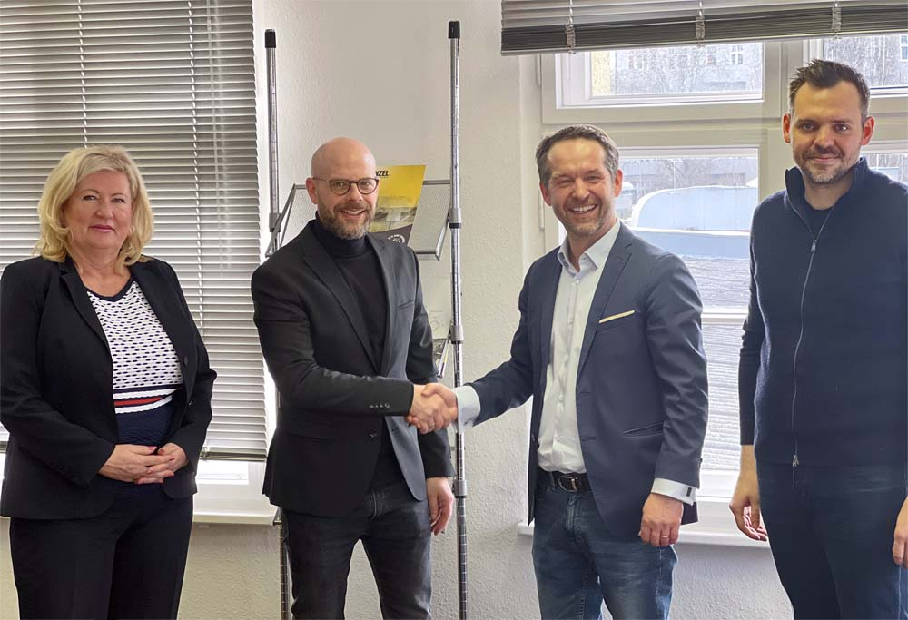
Caption: Menzel and Vollack on the occasion of the signing of the construction contract;
left to right: Cornelia Uhlig, commercial manager, Matthias Jordt, partner & project supervisor, both Vollack GmbH & Co. KG,
Dirk Achhammer, commercial director, Paul Bernhardt, business unit manager & construction project supervisor, both Menzel Elektromotoren GmbH

The Vollack Group, an expert in methodical building conception, oversees planning and construction. Thanks to resource-saving building technology with heat generation from the local heat network, the building will meet the EG40EE energy efficiency standard and thus qualify for funding from the state. “In planning and implementing this project, we emphasize lean processes and resource conservation at all levels,” says Matthias Jordt, partner at Vollack. This generates added value for Menzel, with positive effects on quality, time and costs.
With this investment and the move to the new location, Menzel Elektromotoren positions itself sustainably for the future. The family-owned company, which is celebrating its 95th anniversary this year, stands for high-quality production of powerful electric motors for industrial plants all over the world. Menzel offers several own-brand motor series and is also specialized in customization as well as identical reproduction of existing motors. The company keeps various motor versions up to 15 MW permanently in stock and adapts them at short notice for a wide variety of applications and locations. Furthermore, Menzel offers comprehensive testing services for electric motors, generators, transformer-converter-motor systems, gearboxes and frequency converters, idle tests up to 10 MW, load tests up to 1.8 MW and bifrequency heating testing up to 5 MW.
Updates on building phases: https://www.menzel-motors.com/news/

Image/s: | vollack--uhlig_jordt__menzel--achhammer_bernhardt | Characters: | 2358
File name: | 202202019_pm_new_motor_plant_en | Date: | 02-28-2022
About Menzel Elektromotoren
Based in Berlin, Menzel Elektromotoren GmbH has been manufacturing and distributing electric motors since 1927. The medium-sized company specializes in the delivery of large electric motors, including special models up to 13.8 kV and 20 MW, within the shortest possible time. The product range comprises high and low voltage motors, DC motors, and generators. Services include motor production and short-term adaptation of stocked motors to application-specific requirements. In order to ensure fast deliveries to the customer at all times, the company maintains a very extensive inventory including more than 20,000 motors with a maximum performance of up to 15,000 kW. Qualified engineering, experienced staff, and state-of-the-art production and testing facilities help Menzel provide excellent reliability. Menzel operates subsidiaries in the UK, France, Italy, Spain, Rumania, and Sweden, and cooperates with numerous partners worldwide.
Contact:  Menzel Elektromotoren GmbH  Mathis Menzel  Neues Ufer 19-25  10553 Berlin  Germany  Phone: +49 . 30 . 349 922-0  Email: info@menzel-motors.com  Internet: www.menzel-motors.com |  | gii die Presse-Agentur GmbH  Immanuelkirchstr. 12  10405 Berlin  Germany  Phone: +49 . 30 . 538 965-0  Email: info@gii.de  Internet: www.gii.de

