Press Release

Control tradeshow preview:
Vision building kit in live performance tests

At the upcoming Control trade fair in Stuttgart, Germany, autoVimation will be showcasing new protective camera enclosures and complete machine vision installations for industrial environments and hygienic processes as part of the special Fraunhofer Vision show “Non-contact measurement technology”. Along with the premiere of the new Elephant enclosure series for larger camera cross-sections up to 100 mm x 100 mm, there will be live demonstrations of autoVimation’s effective passive cooling by up to 25 °K through the patented camera mounting inside the protective enclosure and of water cooling with and without protective enclosure – the German company manufactures temperature management solutions for machine vision applications in all climate zones as well as climate chambers.

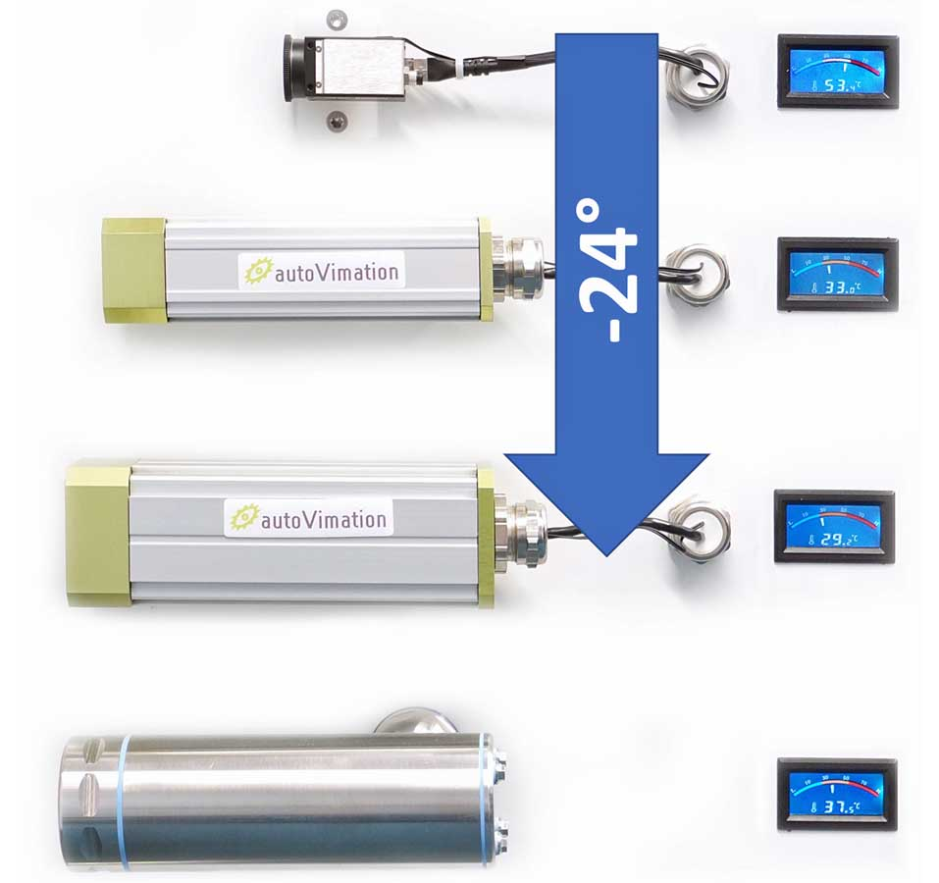
Caption: autoVimation showcases various working models, demonstrating, among other things, its effective passive cooling of cameras through excellent heat dissipation to the outer enclosure

In the “Snow globe” demo model, wind curtains, air nozzles and protective flaps ensure a clear view under difficult conditions as can occur for instance in the steel and paper industries. The programmable Meganova ring light is demonstrated in a demanding image capture setup, taking sharp pictures of a fan rotating at 50 km/h. Sample installations based on the “Machine Vision Building Kit” and its counterpart in hygienic design show how image processing technology can be flexibly assembled and positioned in different manufacturing environments, using modular components. The “Hygienic Machine Vision Building Kit”, made of stainless steel for processes with regular high-pressure cleaning, enables the legally compliant installation of vision systems in food and pharmaceutical processes according to strict EHEDG specifications.
autoVimation at Control
Stuttgart, Germany, 23 – 26 April 2024
Fraunhofer special show “Non-contact measurement technology”
Hall 8, Stand 8202

Image/s: | passive_cooling_demo | Characters: | 1621
File name: | 202402028_pm_control_tradeshow_preview_en | Date: | 02-27-2024
About autoVimation
Founded in 2008, autoVimation is a pioneer in the design and production of industrial-grade protective camera enclosures and a complete building kit for the simple, cost- and time-saving installation of image processing components. Vision system integrators, OEMs, plant manufacturers and operators worldwide find the German manufacturer a trusted source for enclosures in various sizes as well as a huge modular range of dovetail profiles, clamps and angles for flexible positioning and adjustment of cameras, lasers and other components above production lines and in all kinds of industrial and other settings. Once aligned, all connectors ensure permanently stable fixation with up to 2000 N displacement force and 90 Nm torsion resistance. The patented Quick-Lock/Heat-Guide camera mount provides excellent heat dissipation and enables flexible camera positioning inside the protective enclosure. autoVimation’s powerful LED ring lighting with a flash controller also stays cool thanks to good heat coupling to the outer enclosure and, mounted directly behind the window, is protected according to IP67. An extensive range of accessories enables camera technology to be used under challenging conditions: protective flaps and wind curtains for particularly dirty installation environments and temperature control solutions for ambient temperatures from -40 °C to 250 °C. A complete hygienic modular building kit in accordance with strict EHEDG specifications enables the legally compliant installation of image processing components in food or pharmaceutical processes.
Contact:  autoVimation GmbH  Peter Neuhaus  Roemerweg 1  76287 Rheinstetten  Germany  Phone: +49 . 721 . 627 6756  Email: sales@autovimation.com  Internet: www.autovimation.com |  | gii die Presse-Agentur GmbH  Immanuelkirchstr. 12  10405 Berlin  Germany  Phone: +49 . 30 . 538 9650  Email: info@gii.de  Internet: www.gii.de

