Press Release

Optical Ex-i level sensors with more process interfaces

EGE-Elektronik has revised its intrinsically safe optical level sensors for liquids with ATEX/IECEx approval for use in Zone 0 and is launching the new, improved UF2 series. The optical measuring principle works independently of the dielectric constant or conductivity of the liquid. This sets the sensors apart from conductive, capacitive or microwave-based level controllers, which are unreliable in detecting liquids with a low dielectric constant. The UF2 optical sensors, on the other hand, also accurately detect these media, which include many hydrocarbon compounds, solvents and oils. Featuring a glass tip, the level sensors are also suitable for detecting kerosene or gasoline. The case is made of 1.4571 stainless steel. The improved series boasts various process interfaces such as G-thread, NPT thread, cutting ring fitting, triclamp or flange. Depending on the type, the sensor’s electrical connection is made via M12 connector, cable or clamping space. Customers can specify the required sensor and cable length for individual configuration. The level sensors are only intended for operation with an IKMb 123 Ex series evaluation device for DIN rail mounting, which provides a relay/changeover output and can be operated at 24 V DC or 115 V AC or 230 V AC, depending on the model.

The UF2 series will have its premiere at the SPS trade fair.
EGE at SPS
Nuremberg, Germany, 12 – 14 November 2024
Hall 7A, Booth 111

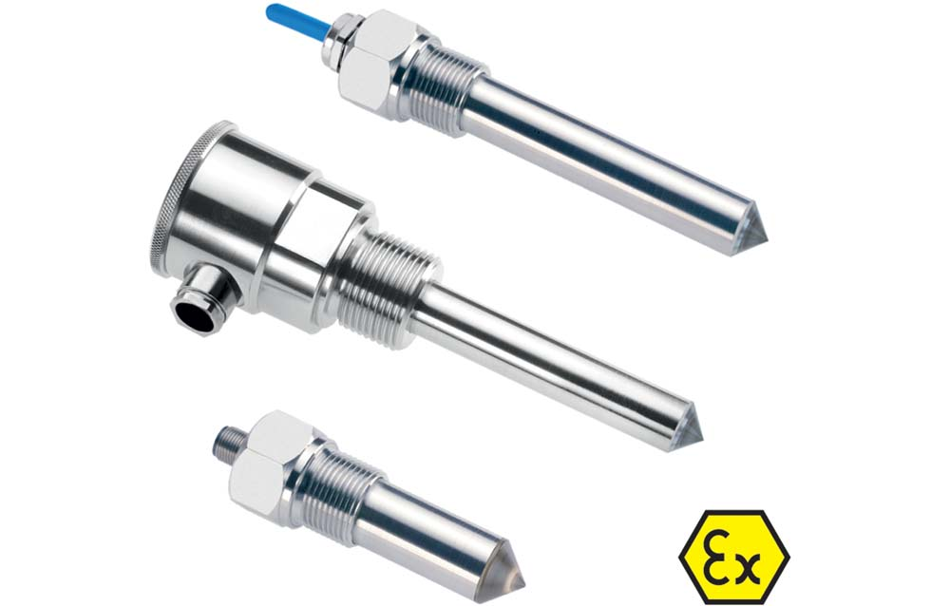
Caption: Operating according to the optical measuring principle, UF2 level sensors with ignition protection type Ex i, intrinsic safety, detect a wide range of liquids regardless of permittivity or conductivity

Image/s: | ege_uf2_level_sensors | Characters: | 1295
File name: | 202410038_pm_uf2_level_sensors_en | Date: | 10-28-2024
Tags: | level sensors, level controllers, ATEX, IECEx, intrinsically safe, intrinsic safety, Ex i, SPS trade fair
About EGE
EGE-Elektronik Spezial-Sensoren GmbH has been developing and manufacturing special purpose sensors for automation applications since 1976. The company serves leading international producers from a wide range of industries. Its product portfolio includes flow controllers, infrared, opto and ultrasonic sensors, capacitive proximity switches, light barriers and inductive proximity switches. EGE also provides sensors for highly sensitive applications, e.g. hazardous areas. The development department's highly qualified staff cooperates closely with all customers, ensuring continuous product updates and enhancement. A total of 130 employees, including 20 engineers and technicians, generate gross sales of approx. 19.5 million Euros worldwide.
Contact:  EGE-Elektronik Spezial-Sensoren GmbH  Sven-Eric Hiss  Ravensberg 34  24214 Gettorf  Germany  Phone: +49 4346 4158-0  Email: info@ege-elektronik.com  Internet: www.ege-elektronik.com |  | gii die Presse-Agentur GmbH  Christburger Str. 41  10405 Berlin  Germany  Phone: +49 30 538 965-0  Email: info@gii.de  Internet: www.gii.de

